PRACTICAL FILE
(No Code (Excel & Power BI) CSU1888



Submitted by Submitted to
Lovisha Arora Dr. Ruchika Sharma
(GF202569037)

Faculty of Bioengineering and Food Technology
Shoolini University of Biotechnology and Management Sciences
Solan, H.P

PROGRAM 1: Write a program to print “Hello World”.
#include <stdio.h>
int main() {
printf("Hello World");
return 0;
}

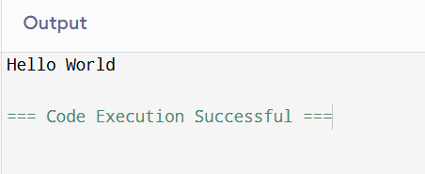

PROGRAM 2: Write a program to calculate the area of a rectangle.
#include <stdio.h>
int main() {
float length, breadth, area;
printf("Enter length and breadth: ");
scanf("%f %f", &length, &breadth);
area = length * breadth;
printf("Area of rectangle = %.2f", area);
return 0;
}

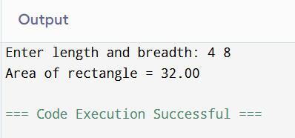

PROGRAM 3: Write a program to print the name, age, and height of a person.
#include <stdio.h>
int main() {
char name[50];
int age;
float height;
printf("Enter name: ");
scanf("%s", name);
printf("Enter age: ");
scanf("%d", &age);
printf("Enter height (in cm): ");
scanf("%f", &height);
printf("Name: %s\nAge: %d\nHeight: %.2f cm", name, age, height);
return 0;
}

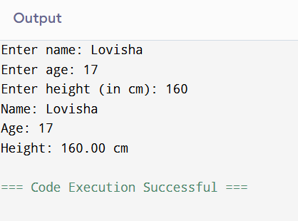

PROGRAM 4: Write a program to calculate the sum of two numbers.
#include <stdio.h>
int main() {
int a, b, sum;
printf("Enter two numbers: ");
scanf("%d %d", &a, &b);
sum = a + b;
printf("Sum = %d", sum);
return 0;
}

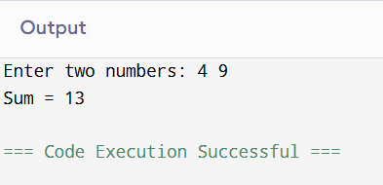

PROGRAM 5: Write a program to calculate simple interest.
#include <stdio.h>
int main() {
float p, r, t, si;
printf("Enter principal, rate, and time: ");
scanf("%f %f %f", &p, &r, &t);
si = (p * r * t) / 100;
printf("Simple Interest = %.2f", si);
return 0;
}

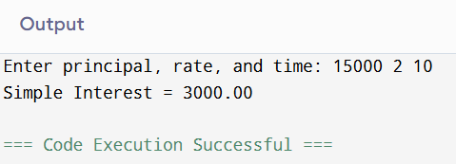

PROGRAM 6: Write a program for Pre & Post Increment & Decrement.
#include <stdio.h>
int main() {
int a = 5;
printf("a = %d\n", a);
printf("Pre-increment: %d\n", ++a);
printf("Post-increment: %d\n", a++);
printf("After post-increment: %d\n", a);
printf("Pre-decrement: %d\n", --a);
printf("Post-decrement: %d\n", a--);
printf("After post-decrement: %d", a);
return 0;
}

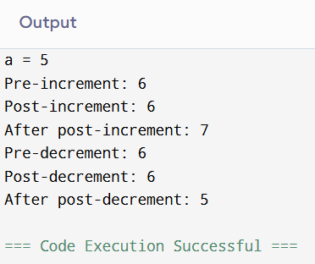

PROGRAM 7: Write a program showing all the operators.
#include <stdio.h>
int main() {
int a = 10, b = 5;
printf("Arithmetic: %d %d %d %d %d\n", a+b, a-b, a*b, a/b, a%b);
printf("Relational: %d %d %d %d %d %d\n", a>b, a<b, a>=b, a<=b, a==b, a!=b);
printf("Logical: %d %d %d\n", (a>b && b>0), (a<b || b>0), !(a<b));
printf("Assignment: %d\n", a+=b);
printf("Bitwise: %d %d %d\n", a&b, a|b, a^b);
return 0;
}
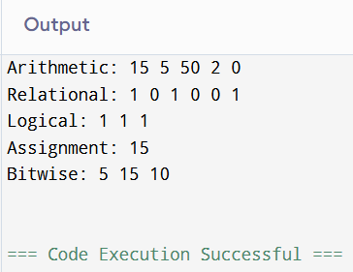

PROGRAM 8: Write a program to convert centigrade to Fahrenheit.
#include <stdio.h>
int main() {
float c, f;
printf("Enter temperature in Celsius: ");
scanf("%f", &c);
f = (c * 9 / 5) + 32;
printf("Temperature in Fahrenheit = %.2f", f);
return 0;
}

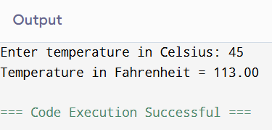

PROGRAM 9: Write a program to check whether the input number is odd or even.

Conditional Syntax:
if (condition) {
// statements
} else {
// statements
}

#include <stdio.h>
int main() {
int n;
printf("Enter a number: ");
scanf("%d", &n);
if (n % 2 == 0)
printf("Even");
else
printf("Odd");
return 0;
}

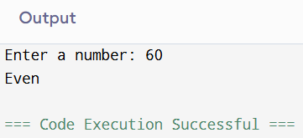

PROGRAM 10: Write a program to check whether the user is eligible to vote or not.
#include <stdio.h>
int main() {
int age;
printf("Enter your age: ");
scanf("%d", &age);
if (age >= 18)
printf("Eligible to vote");
else
printf("Not eligible to vote");
return 0;
}
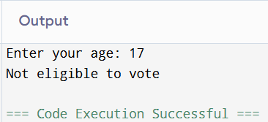

PROGRAM 11: Write a program to input grades of students.
#include <stdio.h>
int main() {
int marks;
printf("Enter marks: ");
scanf("%d", &marks);
if (marks >= 90)
printf("Grade A");
else if (marks >= 75)
printf("Grade B");
else if (marks >= 50)
printf("Grade C");
else
printf("Grade F");
return 0;
}

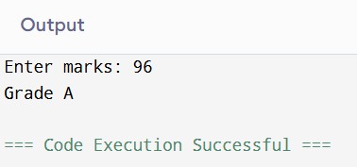

PROGRAM 12: Write a program to find the greatest number.
#include <stdio.h>
int main() {
int a, b, c;
printf("Enter three numbers: ");
scanf("%d %d %d", &a, &b, &c);
if (a > b && a > c)
printf("%d is greatest", a);
else if (b > c)
printf("%d is greatest", b);
else
printf("%d is greatest", c);
return 0;
}
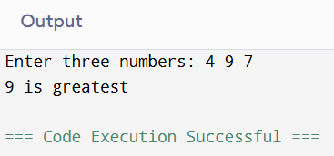

PROGRAM 13: Write a program to calculate the electricity bill.
#include <stdio.h>
int main() {
float units, bill, total;
printf("Enter units consumed: ");
scanf("%f", &units);
if (units <= 100)
bill = units * 1.5;
else if (units <= 200)
bill = 100 * 1.5 + (units - 100) * 2.0;
else
bill = 100 * 1.5 + 100 * 2.0 + (units - 200) * 3.0;
total = bill + (0.2 * bill);
printf("Total Bill = %.2f", total);
return 0;
}
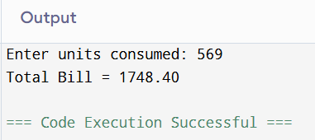

PROGRAM 14: Write a program to calculate income tax.
#include <stdio.h>
int main() {
float income, tax = 0;
printf("Enter your income (in lakhs): ");
scanf("%f", &income);
if (income <= 2.5)
tax = 0;
else if (income <= 5.0)
tax = (income - 2.5) * 0.05;
else if (income <= 10.0)
tax = (2.5 * 0.05) + (income - 5.0) * 0.20;
else
tax = (2.5 * 0.05) + (5.0 * 0.20) + (income - 10.0) * 0.30;
printf("Tax to be paid = %.2fL", tax);
return 0;
}

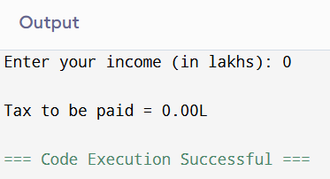

PROGRAM 15: Write a program to find whether the entered year is a leap year.
#include <stdio.h>
int main() {
int year;
printf("Enter year: ");
scanf("%d", &year);
if ((year % 400 == 0) || (year % 4 == 0 && year % 100 != 0))
printf("Leap year");
else
printf("Not a leap year");
return 0;
}
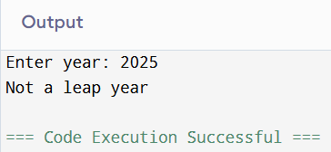

PROGRAM 16: Write a program to determine whether a character is lowercase or uppercase.
#include <stdio.h>
int main() {
char ch;
printf("Enter a character: ");
scanf(" %c", &ch);
if (ch >= 'A' && ch <= 'Z')
printf("Uppercase");
else if (ch >= 'a' && ch <= 'z')
printf("Lowercase");
else
printf("Not an alphabet");
return 0;
}
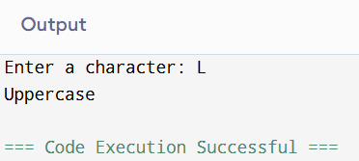

PROGRAM 17: Write a program to create a simple calculator using switch-case.

Switch Syntax:
switch(expression) {
case value1:
// code
break;
default:
// code
}

#include <stdio.h>
int main() {
char op;
float a, b;
printf("Enter operator (+, -, *, /): ");
scanf(" %c", &op);
printf("Enter two numbers: ");
scanf("%f %f", &a, &b);
switch(op) {
case '+': printf("Result = %.2f", a + b); break;
case '-': printf("Result = %.2f", a - b); break;
case '*': printf("Result = %.2f", a * b); break;
case '/': printf("Result = %.2f", a / b); break;
default: printf("Invalid operator");
}
return 0;
}
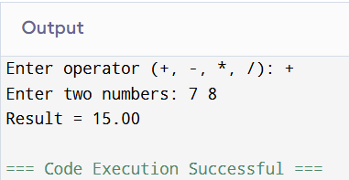

PROGRAM 18: Write a program to check whether a number is positive, negative or zero.
#include <stdio.h>
int main() {
int n;
printf("Enter a number: ");
scanf("%d", &n);
if (n > 0)
printf("Positive");
else if (n < 0)
printf("Negative");
else
printf("Zero");
return 0;
}
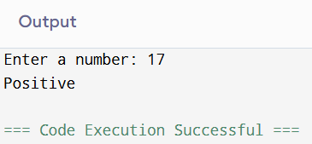

PROGRAM 19: Write a program to check whether a number is divisible by both 5 and 11.
#include <stdio.h>
int main() {
int n;
printf("Enter a number: ");
scanf("%d", &n);
if (n % 5 == 0 && n % 11 == 0)
printf("Divisible by both 5 and 11");
else
printf("Not divisible by both 5 and 11");
return 0;
}
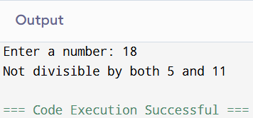

PROGRAM 20: Write a program to check whether a character is an alphabet, digit, or special character.
#include <stdio.h>
int main() {
char ch;
printf("Enter a character: ");
scanf(" %c", &ch);
if ((ch >= 'a' && ch <= 'z') || (ch >= 'A' && ch <= 'Z'))
printf("Alphabet");
else if (ch >= '0' && ch <= '9')
printf("Digit");
else
printf("Special character");
return 0;
}
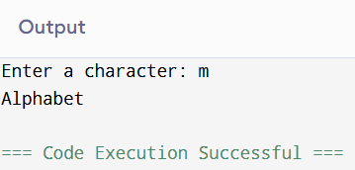

PROGRAM 21: Write a program to print the day of the week using switch-case.
#include <stdio.h>
int main() {
int day;
printf("Enter day number (1-7): ");
scanf("%d", &day);
switch(day) {
case 1: printf("Monday"); break;
case 2: printf("Tuesday"); break;
case 3: printf("Wednesday"); break;
case 4: printf("Thursday"); break;
case 5: printf("Friday"); break;
case 6: printf("Saturday"); break;
case 7: printf("Sunday"); break;
default: printf("Invalid");
}
return 0;
}
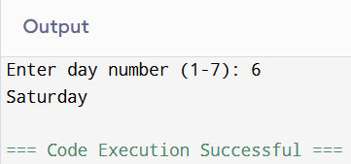

PROGRAM 22: Write a menu-driven program to calculate area.
#include <stdio.h>
int main() {
int choice;
float r, l, b, base, h;
printf("1. Circle\n2. Rectangle\n3. Triangle\nEnter choice: ");
scanf("%d", &choice);
switch(choice) {
case 1:
printf("Enter radius: ");
scanf("%f", &r);
printf("Area = %.2f", 3.14 * r * r);
break;
case 2:
printf("Enter length and breadth: ");
scanf("%f %f", &l, &b);
printf("Area = %.2f", l * b);
break;
case 3:
printf("Enter base and height: ");
scanf("%f %f", &base, &h);
printf("Area = %.2f", 0.5 * base * h);
break;
default:
printf("Invalid choice");
}
return 0;
}
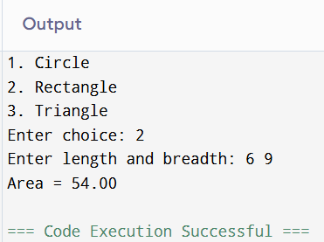

LOOP SYNTAX (FOR, WHILE, DO-WHILE):
// For Loop
for (initialization; condition; increment) { statements; }

// While Loop
while (condition) { statements; }

// Do-While Loop
do { statements; } while (condition);

PROGRAM 26: Print numbers from 1 to 10 using for loop.
#include <stdio.h>
int main() {
for (int i = 1; i <= 10; i++)
printf("%d\n", i);
return 0;
}
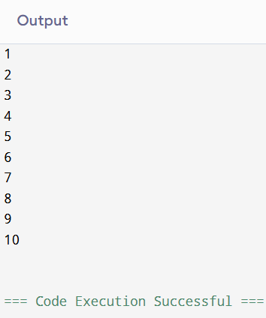

PROGRAM 27: Print even numbers from 1 to 20 using for loop.
#include <stdio.h>
int main() {
for (int i = 2; i <= 20; i += 2)
printf("%d\n", i);
return 0;
}
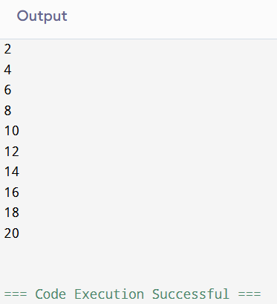

PROGRAM 28: Print multiplication table using for loop.
#include <stdio.h>
int main() {
int n;
printf("Enter number: ");
scanf("%d", &n);
for (int i = 1; i <= 10; i++)
printf("%d x %d = %d\n", n, i, n * i);
return 0;
}
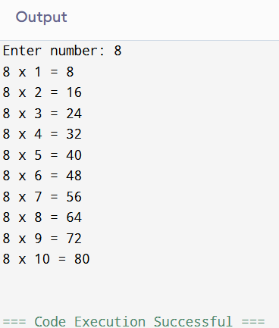

PROGRAM 29: Reverse multiplication table.
#include <stdio.h>
int main() {
int n;
printf("Enter number: ");
scanf("%d", &n);
for (int i = 10; i >= 1; i--)
printf("%d x %d = %d\n", n, i, n * i);
return 0;
}

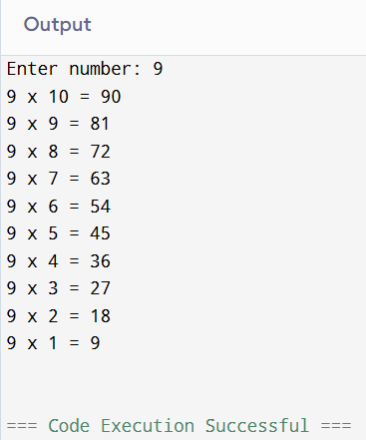

PROGRAM 30: Find factorial of a number.
#include <stdio.h>
int main() {
int n, fact = 1;
printf("Enter number: ");
scanf("%d", &n);
for (int i = 1; i <= n; i++)
fact *= i;
printf("Factorial = %d", fact);
return 0;
}
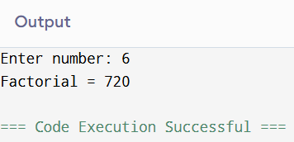

PROGRAM 31: Sum of n natural numbers using for loop.
#include <stdio.h>
int main() {
int n, sum = 0;
printf("Enter n: ");
scanf("%d", &n);
for (int i = 1; i <= n; i++)
sum += i;
printf("Sum = %d", sum);
return 0;
}
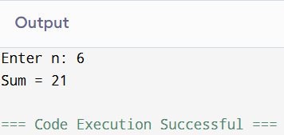

PROGRAM 32: Print numbers 1–20 using while loop.
#include <stdio.h>
int main() {
int i = 1;
while (i <= 20) {
printf("%d\n", i);
i++;
}
return 0;
}

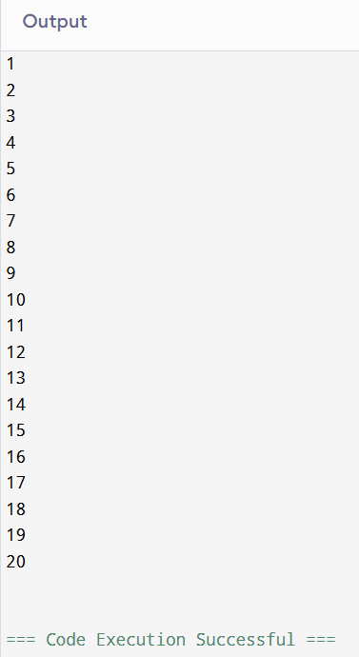

PROGRAM 33: Print even numbers 1–20 using while loop.
#include <stdio.h>
int main() {
int i = 2;
while (i <= 20) {
printf("%d\n", i);
i += 2;
}
return 0;
}
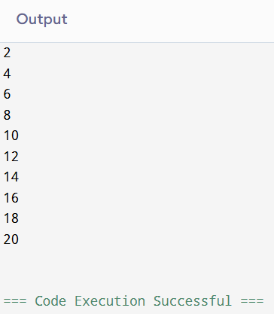

PROGRAM 34: Sum of n natural numbers using while loop.
#include <stdio.h>
int main() {
int n, i = 1, sum = 0;
printf("Enter n: ");
scanf("%d", &n);
while (i <= n) {
sum += i;
i++;
}
printf("Sum = %d", sum);
return 0;
}
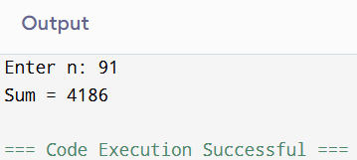

PROGRAM 35: Even numbers in user-defined range (while loop).
#include <stdio.h>
int main() {
int start, end;
printf("Enter start and end: ");
scanf("%d %d", &start, &end);
while (start <= end) {
if (start % 2 == 0)
printf("%d\n", start);
start++;
}
return 0;
}
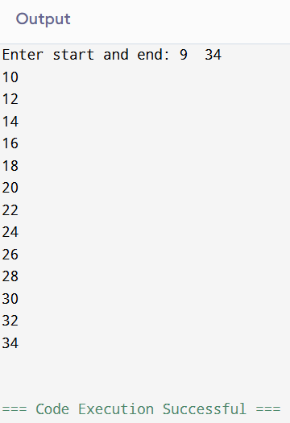

**PROGRAM 36: Even numbers reverse
20–2 (while loop).**
#include <stdio.h>
int main() {
int i = 20;
while (i >= 2) {
printf("%d\n", i);
i -= 2;
}
return 0;
}
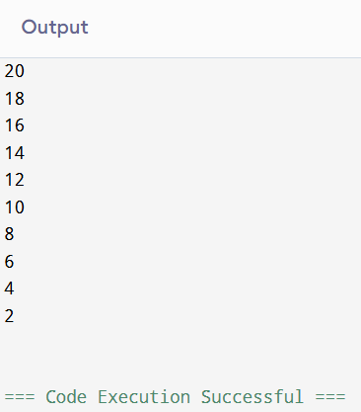

PROGRAM 37: Multiplication table using while loop.
#include <stdio.h>
int main() {
int n, i = 1;
printf("Enter number: ");
scanf("%d", &n);
while (i <= 10) {
printf("%d x %d = %d\n", n, i, n * i);
i++;
}
return 0;
}
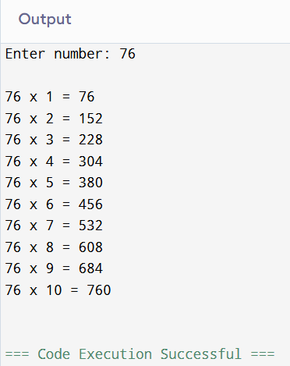

PROGRAM 38: Print numbers 1–20 using do-while loop.
#include <stdio.h>
int main() {
int i = 1;
do {
printf("%d\n", i);
i++;
} while (i <= 20);
return 0;
}
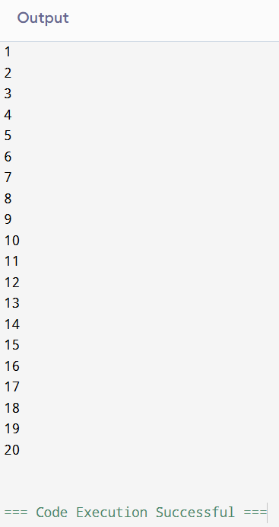

PROGRAM 39: Even numbers in range using do-while loop.
#include <stdio.h>
int main() {
int start, end;
printf("Enter start and end: ");
scanf("%d %d", &start, &end);
do {
if (start % 2 == 0)
printf("%d\n", start);
start++;
} while (start <= end);
return 0;
}
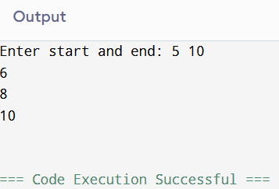

PROGRAM 40: Even numbers reverse 20–2 using do-while loop.
#include <stdio.h>
int main() {
int i = 20;
do {
printf("%d\n", i);
i -= 2;
} while (i >= 2);
return 0;
}
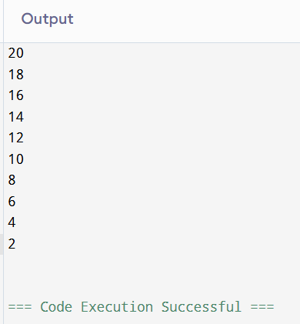

PROGRAM 41: Sum of n natural numbers using do-while loop.
#include <stdio.h>
int main() {
int n, i = 1, sum = 0;
printf("Enter n: ");
scanf("%d", &n);
do {
sum += i;
i++;
} while (i <= n);
printf("Sum = %d", sum);
return 0;
}
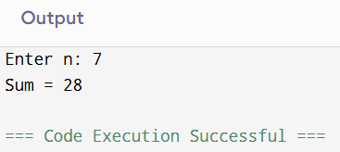

PROGRAM 42: Multiplication table using do-while loop.
#include <stdio.h>
int main() {
int n, i = 1;
printf("Enter number: ");
scanf("%d", &n);
do {
printf("%d x %d = %d\n", n, i, n * i);
i++;
} while (i <= 10);
return 0;
}
